Plumbing, Housing Repair and Personhood: The Politics of Urban Infrastructure in Romania

Liviu Chelcea

ABSTRACT. Social studies of infrastructure generally claim that urban infrastructures are materially and symbolically hidden, arguing that they become visible only when they malfunction. I question that claim, based on the way long-term tenants in nationalized housing in Romania conceptualize plumbing and housing repair as ownership. Without crisis or malfunction, tenants make symbolically visible, collectivize, and politicize the plumbing of capillary endings of urban infrastructure in order to retain occupancy and gain ownership. Plumbing is proprietarian, encoding tenants’ “proper historicity” and custodianship in a wide range of material engagements with houses. These include recompartmentalization-driven plumbing, improved connectivity to municipal gas, water, or electricity networks as well as ordinary running repairs. I describe the theoretical implications of analyzing the flows, materialities, and agencies of plumbing for the ethnographies of houses and urban infrastructure. Plumbing is simultaneously a material, political, and symbolic practice. Future discussions of the links between plumbing, modernity, and anthropology might have potential value for renewed understandings of ethnographic reflexivity.

KEYWORDS: infrastructure, houses, repair, maintenance, property, post-socialism, historical centers, urbanism, urban flows.

Introduction: Plumbing, Housing Repair, and the Visibility of Infrastructure

I was interviewing Sandu, a tenant in on old nationalized house, when a rather strange incident interrupted our conversation when it was already well underway. It started to rain quite heavily that summer’s day in Bucharest. Sandu excused himself saying that he would be back in a second, then rushed out of the room, out of the house, and out of the yard. His house lay at the bottom of a steep street, located in a late-nineteenth-century neighborhood constructed on reclaimed wetlands. As I was looking out the window trying to make sense of this, I saw him run to the middle of the street, open a heavy manhole cover over the sewer, then rush back into the house.
When we resumed the conversation, Sandu briefly explained that, every time there are heavy rains, he needs to open the manhole cover so that the rapid accumulation of water does not flood the basement of the house, or its interior, via the house pipes leading to the bathroom. He excused himself again for the inconvenience and continued the interview. During it, he spoke extensively about repairs to the house that he had occupied for 40 years. He said he felt a deep sense of injustice because the house had been reclaimed by its precommunist owners and their legal claim prohibited him from purchasing it at a rather favorable price. The house, like many others in central Bucharest, had been constructed in the late nineteenth century and nationalized in late 1940s when the Communist Party rose to power. During his family’s tenancy of the house, its heating had been switched from coal to natural gas, which came in through pipes that they had paid for, the plumbing had been replaced, and an additional bathroom and kitchen had been created for the four families that they shared the house with.
During the 1980s many European governments enacted extensive programs of housing privatization. The former communist countries followed suit. With the extinction of the state socialist project in Eastern Europe and the USSR after 1989, state ownership of housing became extinct too. Historically, some of the previously state-owned houses had been constructed by municipalities, some by state companies, while others had been confiscated during the revolutionary nationalization process that took place during the first years of the communist period. Excluded from this macro-historical process, however, were tenants like Sandu, who occupied houses that had been confiscated in the past, but were now being reclaimed by their former owners and their descendants.
When talking about this exclusion, tenants tend to focus on the history of material engagements with and custodianship of the spaces they occupied for years. For Sandu and many other tenants, carrying out personal repairs or hiring plumbers created an entitlement to those houses. Sandu merges in a single narrative the visibility of urban infrastructure, plumbing, and political claims, thus challenging us to think of the cultural location of plumbing. In this article, I argue that plumbing may be a useful analytic tool for increasing our understanding of the politics and materiality of modern houses, as well as the infrastructure of modern cities. I focus on the final capillary elements of urban infrastructures, which lie inside or right next to houses and unite them to the main parts of networks. I seek to describe the kind of personhood that emerges from the plumbing of the infrastructure that supports flows of matter through modern houses.
Anthropological analyses of housing repair have focused on a variety of topics. Older anthropological studies described the relation between the developmental cycle in domestic groups and houses (Fortes 1958) or the biography of houses as they go through specific stages (Kopytoff 1986). Talking about the biographical expectations that we have of houses (and objects in general), Kopytoff (1986:67) mentions that for some people that he studied “the physical state of the hut at each given age corresponds to a particular use.” During the 1990s and 2000s, analyses of housing repair tended to be dominated by an excessive focus on mobile and expressive domestic objects, do-it-yourself processes driven by big retailers and the aestheticization of everyday life. In a way, this mirrored the growth of homeownership in many European countries, as well as the popularity of reality shows featuring home improvement (McElroy 2008, MacDonald 2007:22). Such studies suffer from a redundant focus on the active agency of occupants of homes and their identity politics (Miller 2001, Fehervary 2011). A different approach called for anthropologists to focus on “estate agency”, in other words, “what the home does with us; ... the agency of the home itself” (Miller 2001:4).
Other studies of housing repair focus on do-it-yourself home improvement from the perspective of craft consumption facilitated by human–nonhuman assemblages composed of skills and tools (Watson and Shove 2008). Some other studies of housing repair have centered on gender roles and decision-making processes over the allocation of domestic resources for home improvement (Wilk 1987; Miller 1988; Doucet 2004). The relationship between comfort, technological change, and the social geography of the house has been described by some researchers interested in recent attempts to reduce the carbon footprint of modern houses. Healy (2008) and Wilhite (2009), for instance, show how retrofitting buildings with double-glazed windows combined with the spread of air conditioning has cut off the relation between house and garden, creating, through the suppression of seasonal variation, domestic “thermal monotony.” Finally, another line of research concentrated on the transformations induced by utility companies through connectivity to urban material flows. Van Vliet et al. (2005), for instance, describe the wiring-up of homes and the electrification of housekeeping and repair in terms of the attempts of power producers to generate diurnal electricity consumption rather than consumption based on replacing nighttime gas lighting (unlike water, power is difficult to store).
While each perspective mentioned above is useful, Sandu’s “experience near” points to another theoretical mix. In order to understand plumbing, I follow a different analytical path inspired by urban geography and political ecology (Laporte 1993; Kaika 2004; Kaika and Swyngedouw 2000; Dunn 2007; Anand 2011), social studies of infrastructure, repair, and maintenance (Star 1999, 2002a, 2002b; Graham and Thrift 2007; Graham 2010b) and anthropological studies of property (Humphrey and Verdery 2004). In these bodies of literature there are three assumptions that are key to understanding Sandu’s argument.
First, modern cities are spaces of flows of substances and fluids through large sociotechnological entities (Kaika 2005). Materialized in colossal urban infrastructures, these flows unite actors across scales. Through the urbanization of nature, “the city becomes a perpetual passing through of deterritorialized materials” (Kaika and Swynedouw 2000:120). Conceived that way, modern houses are social extensions of urban infrastructure. Some studies even go so far as to argue that “in some sense, every house is an individually conﬁgured infrastructure for a family or small group, built primarily by selecting commercially available components whose connectivity is ensured by standardized interfaces (e.g. wall outlets, telephone jacks, and television cables)” (Edwards 2003:197).
Second, despite their infrastructural connectivity, modern houses, as Maria Kaika noted, are imagined as autonomous from society and environment, through the exclusion of undesired social and natural elements. The expression of houses’ imagined autonomy is that urban connectivity becomes invisible: “networks disappeared in the underground, materially and symbolically.” (Kaika and Swynedouw 2000:134), becoming part of a naturalized landscape (Edwards 2003:185). Despite operating those exclusions, there are permanent links and continuities between houses and their others: “although natural and social processes remain invisible and are scripted as ‘the other’ to the modern home, they are in fact the precondition for the home's very existence and remain always part and parcel of its inside” (Kaika 2004:266).
Third, most studies agree that invisible infrastructure does become visible but only in moments of crisis and malfunction. Susan Leigh Star (1999:382) states that “the normally invisible quality of working infrastructure becomes visible when it breaks”. Similarly, Maria Kaika (2004:266) states that the “domestic uncanny” of infrastructural connectivity surfaces during moments of crisis. Paul Edwards (2003:185) notes that “the most salient characteristic of technology … is the degree to which most technology is not salient for most people, most of the time.” Graham and Thrift also point out that infrastructures tend to become manifest when “they cease to function or when the ﬂows sustained by them are interrupted.” (2007:8). While these authors do not attribute crisis and visibility to technological determinism, they tend to underplay the human agency and the political gains one may obtain from surfacing infrastructure, materially or symbolically.
Sandu’s actions and conceptualization of repair as ownership contradict the third assumption. To begin with, the pipes added during tenants’ occupation have never disappeared materially from sight. As I will describe below, through a combination of “the building’s recalcitrance” and improvisation, pipes have always been visible (see Figures 1, 2, and 3). While they might not have been symbolically salient prior to the restitution wars, they become so during disputes over the ownership and privatization of nationalized houses. When Sandu talks about his family interventions on the pipes and parts of the house that needed repair, he mobilizes plumbing and politicizes infrastructure, adding symbolic visibility to the already existing material visibility.

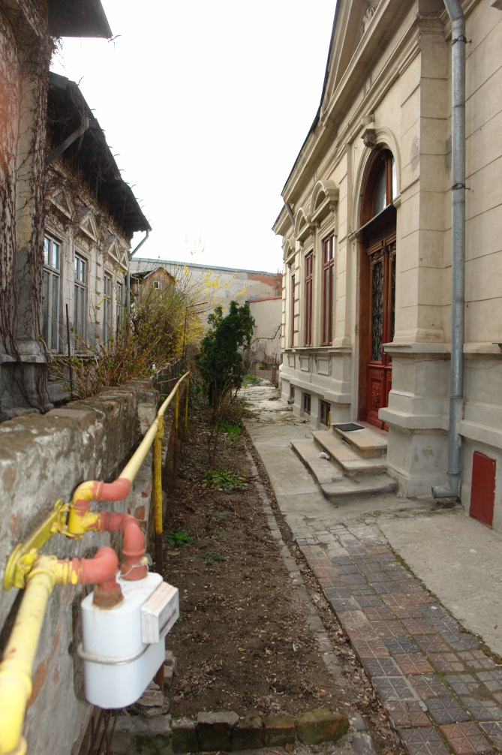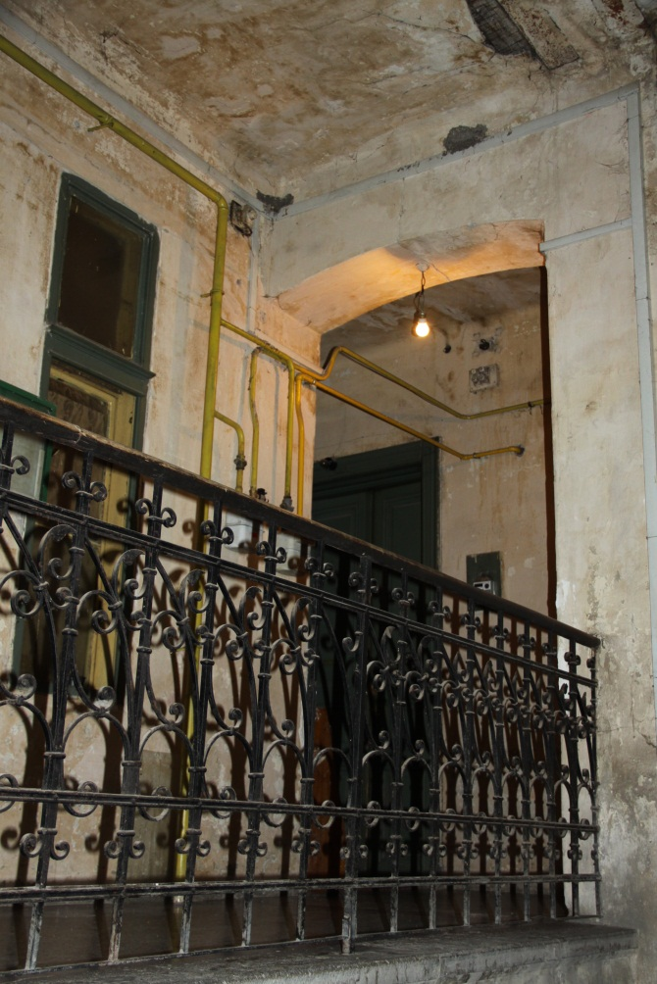

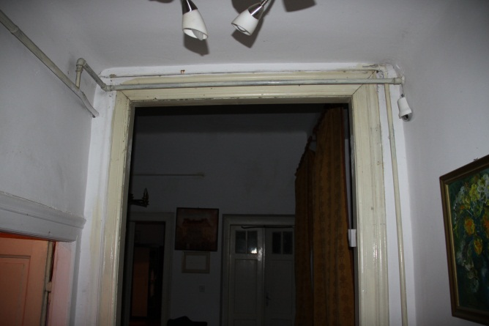
Figures 1 – 3. Materially visible, capillary parts of urban infrastructure, outside and inside buildings (Figure 1 and 2) and apartments (Figure 3). Source: Author’s files.

An ethnographic analysis of plumbing and a new angle on the politics and visibility of infrastructure addresses several theoretical gaps. As mentioned above, one is related to the analysis of the nonexpressive aspects of houses. Following the call to move away from the idea that houses express identity (Miller 2001; Fehervary 2011:21), this study focuses on the “boring things” (Star 2002b) in home life. Water, gas, and power do not belong in the realm of identity politics and are not expressions of taste and difference. As one study put it, the matter whose circulation plumbing makes possible is “uniformly unremarkable and for the most part uniformly uninteresting” (Shove and Chappells 2001:44).
Second, analyzing plumbing may improve our understanding of repair and maintenance. In a critical study of the importance of repair, Graham and Thrift (2007) argue that repair work is often depreciated and normalized. They go as far as to argue that “a major research challenge in the social sciences currently is to re-imagine economies and places in ways which … manage to ‘surface the invisible work’ … of maintenance and repair that continuously surrounds infrastructural connection, movement and ﬂow.” (2007:17). They also notice that, to the extent that repair was analyzed, attention tends to focus on catastrophic rather than prosaic failures (2007:9). Attention paid to plumbing can illuminate such prosaic failures and their social and political effects.
Third, I see an analysis of plumbing as potentially contributing to the study of material culture. Stuart McLean pointed out that, with a few exceptions, “anthropology’s own recent efforts to engage materiality have shown an overwhelming predilection for solids” (2011:591). A close analysis of plumbing may contribute to the understanding of fluids, be they liquid or gaseous. Plumbing makes possible the flow of “good” fluids through the house (clean water, fresh air, or gas), but also blocks “bad” flows of cold air or used and uncontrollable water. The materiality of fluid matter encourages certain practices and actions and prohibits others (see Rogers 2012:293 on this point). Water repairs and improvement can be solved by tenants, whereas gas works require professional attendance.

Politicizing Infrastructure: Plumbing, Improvement, and Custodianship

What kind of plumbing and material engagements did tenants practice during their occupancy? There were three types, with different actors involved and different material constraints and practical logics. The first was recompartmentalization-driven plumbing. Immediately after the 1950 confiscation, the density of people in large bourgeois houses grew dramatically, through allocating one family to each room in large, multi-room apartments. Similarly, auxiliary spaces found in yards (storage areas or summer kitchens) or in marginal house spaces (basements and attics) were transformed into sleeping areas and given to families or individuals. Under such conditions the “building’s recalcitrance” (Yaneva 2008:23) and its inbuilt resistance were fought by replumbing the existing structure to create comfort in the new layout. Instead of one kitchen or bathroom, the buildings were altered so as to have several, an operation that implied substantial plumbing. The new compartmentalization did not follow the initial plans of the buildings; instead ad-hoc improvisations created new spaces of flows inside existing buildings, a process that reinforces Graham and Thrift’s (2007:6) assertion that “maintenance and repair can itself be a vital source of variation, improvisation and innovation. Repair and maintenance does not have to mean exact restoration.”
Second, improvements in network connectivity and retrofitting the buildings also led to plumbing. As these houses were old, most of them were unconnected or only partially connected to the municipal networks created before socialism (water, electricity) or during socialism (gas, central heating – see Collier 2004:50). Many had running water, but not central heating. Most had electric power, but not all house spaces that became livable after nationalization were wired. Most did not have gas pipes, as presocialist and early socialist heating was coal-, oil-, or wood-fired. Therefore the connection of these semi-autonomous houses to the networked flows developed by the state after nationalization involved a major plumbing process, usually carried out at the tenants’ expense.
A major improvement, judging by the money and administrative work involved, was to connect the house or apartment to natural gas pipes. Before the communist period, the domestic technological comfort specific to the early stages of a consumption society was limited to aristocratic and some middle-class homes (mainly those constructed in the late 1930s and 1940s). During the precommunist period (and for many years after 1950) wood was the main fuel used to heat sleeping accommodation as gas pipelines were not widespread in the fabric of Bucharest. Pressurized containers of liquid natural gas, sold at special depots, were used in kitchens, but not for heating. Throughout the communist period, the natural gas pipeline network expanded constantly in Bucharest. Occupants of old houses, many of them tenants of the state, paid with their own money to have their houses connected up. Gas was, at the time, much cheaper than wood. Financial considerations apart, gas was much easier to transport than wood. In the 1950s and 1960s tenants were responsible for the transportation of wood from warehouses to their homes. Later on, trucks delivered wood to their gates or yards, but they still had to chop it up and load it into storage places. Thus, gas was particularly advantageous in regard to saving the effort required to carry wood for heating rooms during winter.
Let me take as an example family G. who, as tenants, invested substantially in their house. The person whom I interviewed grew up there, together with her mother. Their house was quite large. Initially, it was designed as a large, single-apartment house, with many rooms leading directly off a living room. After nationalization, the state housing company transformed it into a rooming house. The interviewee and her parents lived in two rooms. In 1980, the old lady who initially owned the house died, leaving vacant another room – her post-nationalization share of that house. This happened one year after the interviewee had got married and moved to live with her husband in a student dormitory. By placing requests to the state housing company, together with her mother, she nonetheless managed to get an expansion of the family’s living space to include the newly vacant room as well as the attic of the house. She and her husband relocated her mother to that room and kept the original two rooms for themselves.
They also felt that this was a good moment to repair and improve the house. She said that when they moved into the additional space it was in a terrible state. They changed the woodwork of their old and new rooms and painted the walls of the stairway that connected them, also replacing a few broken windows. Then, as they had to share a cooking space and WC with two other neighbors, they decided to turn the attic (initially a storage space) into two separate rooms so that they would no longer have to share with other tenants. They extended the water pipelines to the attic and fitted the two new rooms out as a kitchen and WC. When they installed gas pipes in the house, they also brought gas to the attic, so as to make cooking easier.
Who carried out the repairs? Normally, it should have been the state company that managed state-owned properties. Although from the very moment of nationalization there had been clear state calculations determining how often the fixture and fittings of houses should be replaced, these were not observed. The company, however, especially after 1977 earthquake that shook Bucharest, was short on investment and personnel. It did not have enough carpenters, masons, and plumbers. Ms. G. said that getting such workers to come and do running repairs was a complicated business. The one thing, however, that they did manage to get the state housing company to do was to replace the tin roof of the house, which had started to leak. They also used official procedures to connect “their” house to the gas pipes, especially since, given the possibly fatal consequences of poor installation, correct fitting was essential for tenants, the state housing company, and the gas company. For the rest, rather than relying on the tender mercies of the state housing company – and having to pay them bribes anyway – they decided to employ two plumbers from the informal economy (employed at the state institution where Ms. G. was working). These plumbers purchased the materials and carried out the work required by the G. family over a few months. This kind of arrangement was quite widespread. Rather than wait for years for state housing company workers to repair and rebuild, tenants did the work informally, either by themselves or through employing plumbers.
The third type of plumbing, beside recompartmentalization-driven plumbing and improvements in connectivity, consisted in ordinary running repairs. As Graham and Thrift (2007) suggested, repairing material order is part of the reproduction of social order and it is a continuous process. Buildings themselves are “ﬂows that are always in a state of ﬂux as they strive constantly to fend off decay” (Graham and Thrift 2007:6). It is true that the state housing company carried out structural soundness repairs, but everyday repairs were carried out mainly at tenants’ expense. These ranged from stopping undesired influxes of air (e.g., placing tubular cushions between aging, cracking window frames or bricking up windows altogether – see Figure 4) to stopping water leaks from ancient pipes and repairing roofs, and even included the replacement of old pipework.
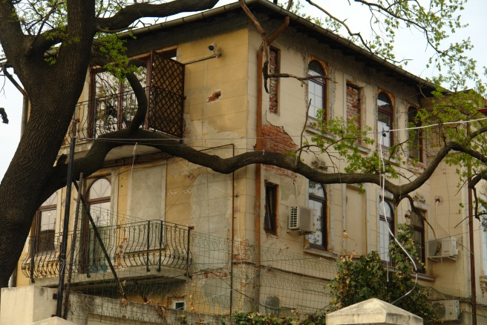

Figure 4 – Blockage of windows by tenants, after nationalization, in order to control air flows and temperature

Prosaic repairs were also occasioned by the process of cleaning a state-owned housing unit when taking up occupancy. People marked their entrance into such spaces with cleaning and other rituals that allowed them to symbolically assume ownership. As Sarah Pink noticed, cleaning up homes previously inhabited by others produces “a sensory and symbolically clean space” (2006:53). As tenancy rights were almost as strong as ownership rights during state socialism, many houses became free only upon a tenant’s death. Prior to death, many occupants were sick and could not clean the houses regularly. When vacancy was caused by something other than death, the official requirement to paint the interior prior to exit was almost never observed. In order to redecorate upon assuming tenancy, people sometimes had to replaster the walls so as to cover the cracks. Some people also had to replace, or at least repair, the woodwork, especially windows. Others repaired or at least cleaned the insides of cast-iron heaters and brick stoves.
Through such material engagements with the buildings they occupied, tenants developed a strong sense of ownership. The de facto ownership acquired through the material transformation of houses is more important, many tenants say, than former owners’ claims based on investment, labor, descent, and primordial rights. For some, it takes priority even over other tenants’ rights to purchase their homes. In a letter sent to the Parliament, a tenant contested the rights of his neighbor to legally privatize her tenancy. The author of the letter had moved in 1980 into a villa constructed in 1938 situated in Bucharest’s residential heaven (District 1). He argued that he had preemptive rights to purchase the entire building, because of his past efforts to repair it. He said that the entire villa was laid out for one household only. He was unhappy that an old lady occupied a room on the ground floor and part of the basement. The letter went on to claim that, since this neighbor was old, she did not contribute anything to the maintenance of the space and, moreover, opposed the consolidation of the entire building (a very costly activity, in particular for a retired person). He and his family assumed the burden of maintenance and repairs, upgrading the villa from what he described as its miserable state when they arrived there. They had invested labor and money and used their special connections at the state housing management company in order to do that. To them, therefore, it seemed only natural that the old lady should not be allowed to buy her share of the building, because “she did not contribute anything to the maintenance of the space.” The strength of the language of custodianship and improvement in such property disputes is noticeable. I came across several such blunt statements stating that tenants are de facto owners. One of them stated that “tenants may not be removed from these houses, because over the years they have become co-owners.”
The symbolic visibility of material engagements is highly selective. While they seem to have a hypermemory for their own investments and material transformations, they are rather silent about former owners’ investment of money, labor, and sentiment. To many tenants, the efforts of the former owners, who constructed those houses and occupied them prior to nationalization, have a finite quality, limited to the prenationalization period. If tenants do acknowledge that the former owners contributed to those houses too by building them, they downplay the importance of their precommunist efforts. One tenant, more sympathetic to the fate of the former owners, said that even before nationalization, especially during the years that immediately preceded the communist regime, it was the tenants who assumed the burden of repair and maintenance. The owners were usually retired people; tenants were younger and employed. Landlords and their children were ostracized by the communist regime, she said, and they were not able to continue investing in the conservation of the housing stock.
It is interesting to note in this context that tenants’ memory of home maintenance is not dominated by monetary evaluations of their efforts. Rather, it is the materiality of their extended presence there comes to the fore. They do not conceptualize their presence financially up to the moment when they go to court. Some of these repairs then become visible and material evidence, which gets juxtaposed with the absence of any material engagements with the building on the part of the state or the former owners.
For some tenants, especially the old ones who may have lived for longer periods of time in nationalized buildings, the repair–connectivity money and rent are, based on abstract equivalences rather than concrete calculations, conceptualized as a mortgage. Some say that, rather than asking for more money, the state should not only have allowed them to own the apartments, it should have given them the nationalized houses for free. One tenant said that

if we were to work out a correct estimate of the costs borne by tenants, taking into account the repair of the houses destroyed in the war, the replacement of their houses’ infrastructure installations (e.g., plumbing), plus taxes and rents, one would see that the apartments bought under Law 112/95 were overpriced and they should be given for free to the tenants rather than for millions [of lei – the Romanian currency].

Another such account, provided by an older person, was explicit about rent being perceived as mortgage repayment. Describing his family relations to their house, he used references such as “identification,” “uninterrupted occupancy,” “improvements,” “flawless behavior,” “fidelity premium.” He said that he had been living there since 1938, for no less than 60 years. He occupied a three-room apartment in a villa. Here is how he viewed his rights and investments into that building:

As tenants of this apartment for three generations, we identified with the destiny of this apartment and with that of the entire building. We paid, therefore, from 1938 through 1950 rent to the authentic owner of this building at the level of that period (12,000 lei – very high). Then we paid at ICRAL for 47 years until today; all in all a period of 60 years. Our apartment was bombed in the 1944 raids, as well as affected by earthquakes (that of 1941 and the subsequent ones). Logically, it was our family who restored the apartment as we have lived here continuously, [including] the minor repairs that are mandatory taking into account the age of the building (80 years). Is there no outcome to such a tenant behavior? Haven’t we perhaps paid the apartment’s value out of our rents, repairs, and improvements? Why don’t they establish a housing fidelity premium that should be attributed to the category of tenants who are like us?

What he emphasized is the link between proper maintenance and ownership. One may speculate on the meaning of such arguments in respect of the way tenants view property rights acquired through material engagements as creating a specific type of personhood. The legal scholar Margaret Radin (1993:58), for instance, argued that U.S. courts often do not grant eviction orders against long-term tenants, because they view leases and attachment to place as personal property. In such situations courts emphasize the fact that home is the site of tenants’ identity and personality and that the doctrine of retaliatory eviction (i.e., allowing landlords to evict tenants without a justified reason at the end of their lease) goes against such personal feelings (Radin 1993:58). Tenants from nationalized houses also point in that direction. Perhaps their point about the personhood acquired by plumbing such dwellings (in opposition to legal rights produced during restitution) was best expressed by one tenant. She said that she told the former owner on one occasion, “Well, you should know one thing: the property [rights] might be yours, but the house [casa] is mine.” Viewing their tenancy as personal property emerges out of a sense of having altered, repaired, and materially invested in the physical structure that they occupy, thus reinforcing McElroy’s (2008:45) idea that “houses become homes through our material re-shaping of them.”
Plumbing represents more than the sum of the individual’s material engagement with houses. It also represents a collective category deployed by tenants, an iconic behavior that circulates in public discourse. Individual, household, or neighborhood housing repairs are collectivized at the level of tenants’ associations. Although I tried hard to get estimates from several structural engineers in order to understand how long building components last, they all said that durability is highly variable depending on the building and that they cannot offer figures that would be good for all. Despite that, during tenants’ meetings individual plumbing and housing are fused into a single collective narrative about repairs as foundational to their rights.
For tenants, the equivalent of John Locke’s (1970) condition of vacancy is the primordial dilapidated state of such houses. Not unlike other doom-laden discourses regarding the privatization of state assets (Alexander 2004), tenants describe how, at the moment of nationalization, the houses were already run down. For instance, at a meeting of the Association of Tenants from Nationalized Houses, an older speaker insisted that whenever a restitution claim is made for a particular house, “one should verify the physical situation and value of the building at the moment of nationalization and at present. In 1950, the state appropriated a shabby cottage, bombed anyway [during World War II] by the Americans and Brits.” This conflation of tenants’ arrival with a state of vacancy and abandonment is not an isolated instance. Another tenant stated that “for 50 years, we, the tenants, kept up and maintained in a satisfactory manner the buildings that are claimed by the owners today[.] Without our efforts, they would have been abandoned ruins since long ago.” Along similar lines, another one said that “throughout the years [after nationalization] these houses were consolidated and modernized, because otherwise they would have fallen apart.” Other tenants evoke the Lockean state of vacancy at the time when they, as a family, moved in there. Here is what one tenant had to say about the length of his residency and his ownership rights:

I was born in 1950. I was not yet born when the house was nationalized and I am not at all guilty vis-à-vis the former owner. I don’t know how long he lived in here and how much he invested in it. But I know that I stayed in this apartment for 17 years and that the state never came to fix any disrepair. I myself and my family sacrificed money, time, labor, and health in order to keep it up, just like a true owner. Under these circumstances, I think that, even before I purchased the apartment [through law 112/1995], I was already to a certain extent its owner.

His personal efforts brought emancipation and freedom, disconnecting him ideologically from the state (Kaika and Swyngedouw 2000:134). Even if the state did not allow their house to be, subjectively, fully autonomous, as modern homes aspire to be, the absentee quality of the landlord state encouraged them, like the G. family (see above), to carry out independent plumbing. Another tenant, in his mid-70s, also emphasized his responsible, “proper” material engagement with his house, saying that “the interior of our home is a model of respect and upkeep.” This man also emphasized that he and his wife expect respect for their personhood based on mixing “unclaimed” materiality with labor: “When we moved here, the house was devastated. We had to pull off and sell our wedding rings and spend another three months of our salaries in order to fix and repair the house.”
Confronted with the denial of their personhood as owners acquired during socialism through acts of restitution to the original owners, tenants experience, as they put it, “abandonment” by the state. Abandonment may be read as the redrawing of the limits of the state and its entrance “into domains where its power can be contested” (Dunn 2007:37), through the creation of “social relations” between tenants and the post-socialist state, in place of the previous situation of cosubstantiality (Alexander 2004; see also Collier 2004). The denial of tenants’ “proper historicity” (Collins 2011) and proprietarian engagements with houses, through restitution instead of privatization, creates a “relational absence” (Alexander 2004:253) with the state.
Miller (1988; 2001) found that public housing tenants in London engaged through material appropriation in the exorcism of the presence of the state from inside their homes. Unlike them, people like Sandu practice “sympathetic magic” relative to the state, hoping to bring it back in. When tenants learn that their house has been reclaimed, they sometimes contact the judicial officials of the state housing company and try to offer them an honorarium so that they (1) bother to defend and (2) defend efficiently the state’s ownership. The Tenants’ Association encouraged them repeatedly in the meetings that I attended to continue to pay the monthly rent to the state housing company (instead of to restituees), after houses have been restituted. The Association’s legal councilors also advised tenants that, once a restitution process begins, they should contract out any plumbing work and housing repairs, keep the receipts, and, should the state housing company lose the trial, sue the former owners for compensation. Whereas before restitution they plumbed houses, after it they plumb the limits of the withdrawing state. If they lose not only the right to buy, but also get evicted from the houses they occupied, they sometimes materially engage with houses once again – but negatively, that is through the disruption and dismemberment upon eviction of the very plumbing and repairs they initiated in the past.

Conclusions: Plumbing, Modernity, and Anthropology

Materiality has been “a particularly revealing site for the investigation of the effects of the fall of state socialism on practices, values and subjectivities.” (Fehervary 2011:370; see also Drazin 2002; Collier 2004, 2011; Fehervary 2009; Buchli 1999; Makovicky 2009) In this article, I have asked what kind of personhood plumbing created for people who materially engaged with their houses repeatedly, even though they were tenants. They conceptualize plumbing in connection with ownership, by making symbolically visible and politicizing the capillary parts of urban infrastructure during their disputes. Making visible and political both infrastructure and plumbing, independent of breakdown as many studies currently argue, has at least three theoretical implications. One bears on politics and materiality, another on agency, and a third on scale and totality in the ethnographic studies of infrastructure. I conclude with some remarks about the cultural life of plumbing, with special reference to the nature of modernity and to its occasional naturalization in anthropological texts.
The first point relates to the politics of materiality. While there have been various understandings of the politics of urban flows and infrastructure, they have generally pointed to inequalities in use rights (Anand 2011). Such studies have not pointed to the ownership rights entailed by material engagements with infrastructure. Tenants use two idioms of ownership in their politics of plumbing. One is Lockean and revolves around improvement and the creation of modern comforts in old buildings through infrastructural connectivity. The other is proprietarian and places plumbing in relation to the state and tenants’ place in society. The ownership entailed in the politics of plumbing is a form of custodianship of a house and a proprietarian understanding of the individual’s role in society.
The second implication is about the agency of houses. Disciplinary conventions have traditionally assigned the study of urban infrastructures to engineers, while architects and urban planners dealt with the “visible” aspects of urban design (Gandy 2004:364). Although there is a long tradition of anthropological studies of houses, they have not generally taken into account the connections with urban infrastructures for gas, water, or electricity. This is noticeable, for instance, in the way anthropologists draw house plans, without representing flows of matter through modern homes. In the last decade, a new wave of research on houses has suggested that one should focus on the agency of houses themselves (Miller 2001). If, however, modern houses are social extensions of infrastructural networks (Edwards 2003:197), then Miller’s insight relies on the same representation, that of the house as an autonomous, unnetworked space, which social studies of urban infrastructure criticize (Kaika and Swyngedouw 2000; Kaika 2004). In addition to “estate agency,” one needs to conceptualize houses at the intersection of human agency, the agency of urban infrastructures, and the agency of the flows and matter that networks regulate. Thus, modern house dynamics lie at the intersection of the sedentarist agency of previous material accumulations in the house with a more diffuse agency located in its infrastructural connectivity.
The final implication is more methodological and bears on the scale of the ethnography of infrastructure. While framing the city and the house as networked infrastructures of flow is a useful approach, social studies of infrastructure often postulate a totality of the network, which is difficult to sustain ethnographically. Dalakoglu (2010:133), for instance, suggests that, analyzed at a micro scale, highways gain localized meanings thus challenging “the prescribed principles of global political economy of motorways.” While cities may be networked spaces (Kaika 2005; Hommels 2005; Coutard and Guy 2007), such studies often lack a localized ethnographic lens. Urban infrastructure may be holistic, big, and stable, but the capillary parts and the way they localize meaning seem to be understudied. Though Star argues that infrastructures generate communities of practices (1999; 2002a), their form and meaning are local and contingent, rather than shared across the whole of a particular infrastructure.
As an analogy, one may think of postmodernist critique of political economy’s sense of totality, which suggested that ethnography should not rely on an a priori sense of totality, but rather trace a sense of connection between sites (Marcus 1995). If one replaces the totality of colonialism or capitalism with that of infrastructure, one needs to reconstruct the scale of infrastructure from the “native’s point of view.” It is what Kim Fortun (in Marcus 2005:18) seems to suggest when claiming that “in keeping ethnography accountable to subject perspectives, a distributed knowledge system is not mappable outside the derivation of it from subject points of view. Keeping ethnography ethnographic in the Malinowskian sense means not falling for the temptation to allow given networks or technical systems to be the objective space of ethnography.” While matter flowed through the tenants’ pipes, it united for them, selectively, not an entire network but their house, street-level sewers, neighbors, the cashier who cashed the monthly bills, professional plumbers, and some abstract idea of “them” (the state), the ones who delivered water, power, or gas. They were unaware of the origins, trajectories, or the destination of the fluids passing through their houses. The circulation of fluids produced a sense of ownership for them, while for others it produced totally different political effects or none at all. An a priori sense of network’s totality and “context” does not, by itself, reveal meaning.
Sandu is not the only one who politicizes plumbing and makes visible infrastructure. As modern homes and cities are networked spaces, plumbing and plumbers are easily accessible and naturalized metaphors. Plumbing is not just a material, political, and symbolic practice, but also a metaphor “that we live by.” The ubiquity of infrastructure and its naturalization into everyday life make plumbing, occasionally, an accessible container to a variety of political, cultural, and scientific commentaries. If one accepts that objects help reproduce localized social order (Preda 1999), connectivity to the metaphor of plumbing helps reproduce categories of the normal and abnormal, the familiar and the exotic, the naturalized and the denaturalized.
Plumbing imaginary framed the exposure of communication infrastructure of U.S. diplomacy during the “Wikileaks” scandal (Roberts et al. 2011). The organized movement of people with disabilities in the U.S. in the 1970s began by exposing “the countless ways in which machines, instruments, and structures of common use – busses, buildings, sidewalks, plumbing fixtures and so forth – made it impossible … to move about freely” (Winner 1980:125). The avant-garde movement’s preference for plumbing equipment is well known. Marcel Duchamp used the urinal to question what constitutes art. The active agency of plumbing, manifested though “hydraulic regurgitations” of one Victorian house at Oxford, UK, prompted Homi Bhabha’s reflections on the “unhomely,” understood as the “paradigmatic postcolonial experience” (Bhabha 1992:141–142).
The politicized, collectivized, and iconic figure of the plumber becomes occasionally a key historical actor. The 2008 U.S. presidential campaign witnessed Joe the Plumber’s odyssey, three decades after White House “Plumbers” generated Watergate. The 2000s European Union’s eastern enlargement was dominated by the specter of the “Polish Plumber.” European conservatives feared the cheap labor force from the East, socialists fought back for workers unity (the Swiss Socialist Party was said to use the slogan “Plumbers of all countries, unite!”), while the Polish government appropriated the image of the plumber in order to attract European tourists. Infrastructure is also made visible in official openings and countercultural movements (Graham 2010a:7–8), as well as during the organized violence entailed by the “war on terror” (Graham 2010a; O’Neill 2012).
The imaginary of financial markets sometimes relies on plumbing and plumbers to “repair” national and international institutions which channel capital “flows.” One such text, called “Plumbing and Visionaries: Securities Settlement and Europe’s Financial Markets” deals with the regionalization and globalization of financial markets and states that the exchange of securities (i.e., clearing and settlement) is “often regarded as the ‘plumbing’ of securities markets: a series of electronic ‘pipes’ linking customers with electronic ‘storage tanks’ which keep customers’ securities accounts” (Norman 2007:4). In another text, called “Housekeeping and Plumbing: The Investability of Emerging Markets,” plumbing stands for national legal and regulatory frameworks compatible with foreign flows of capital, while housekeeping stands for stability and predictability. In discussions of labor markets, the plumber stands for persons with market-compatible skills, as opposed to those inclined to pursue allegedly non-marketable skills involving an excessively long education (an education in French literature and a doctorate in the breeding habits of butterflies are singled out in one such critique).
At a global scale, plumbing indexes Western modernity and distance from it. As in colonial discourses, plumbing and water consumption were for Alfred Loos, one of the key theoreticians of modernist architecture, the absolute index of modernity. In his text called Plumbers 1997[1898], written after his return to his native Austria from the U.S., he decried the wide plumbing gap: “We are backward. Some time ago I asked an American lady what seemed to her was the most notable difference between Austria and America. She answered: the plumbing! – the utilities, the heating, the lighting, and the water pipes. Our faucets, sinks, water closets, and washstands are still far, far inferior to English and American fittings. … In this regard America is to Austria what Austria is to China” (Loos 1997[1898]:17). Conceived as a cultural critique, his praise of the infrastructure and connectivity of the modern house and his fierce attack on façade ornament led to the focus of the next generations of architects on the connectivity of the modern home.
Anthropology connects too, occasionally, to the metaphor of plumbing. Leslie White (1943), illustrating cultural evolution, mentions plumbing as an example of the changes in American society between Lincoln’s presidency and the first half of the 20th century. In many anthropological introductory textbooks and confessional texts about ethnographic experience one occasionally finds plumbing as an indication of how different a culture is. Plumbing functions as the main unit of measurement of cultural distance (e.g., Tomaselli 2001, especially p. 286), culture shock (e.g., Mazzeo 1999) or, in Western settings, social exclusion. To the amusement of Anthro 101 students, stories about lack of plumbing during fieldwork are an easy way to grasp the experience of culture shock. Plumbing seems to function as a measurement of how much they have become like us, but also of the extent to which the ethnographer has become (marginally) native by getting used to the lack of plumbing and local bodily practices. Just as Sandu felt that getting outside the comfort zone of the house while plumbing made him an owner, ethnographers’ own experience during fieldwork and the successive labor of plumbing the meaning, truths, and narratives of the people that we study while writing up makes us the owners of ethnographic texts.

References

Alexander, Catherine
2004 Value, Relations and Changing Bodies. In Property in Question. Caroline Humphrey and Katherine Verdery, eds. Pp. 251–274. Oxford: Berg.
Anand, Nikhil
2011 Pressure: The PoliTechnics of Water Supply in Mumbay. Cultural Anthropology 26(4):542–564.
Bhabha, Homi
1992 The World and the Home. Social Text 31/32:141–153.
Buchli, Victor
1999 An Archeology of Socialism. Oxford: Berg.
Collier, Stephen
2004 Pipes. In Patterned Ground. Stephan Harrison, Steven Pile and Nigel Thrift, eds. Pp. 50-52. London: Reaktion Books.
2001 Post-Soviet Social. Princeton: Princeton University Press.
Collins, John
2011 Melted Gold and National Bodies. American Ethnologist 38(4):683–700.
Coutard, Olivier and Simon Guy
2007 STS and the City. Science, Technology and Human Values 33(6):713–734.
Dalakoglu, Dimitris
2010 The Road: An Ethnography of the Albanian–Greek cross-border Motorway. American Ethnologist 37(1):132–149.
Doucet, Andrea
2004 “It’s Almost Like I Have a Job, but I Don’t Get Paid”: Fathers at Home Reconfiguring Work, Care and Masculinity. Fathering 2(3):277–303.
Drazin, Adam
2002 Chasing Moth. In Markets and Moralities. Ruth Mandel and Caroline Humphrey, eds. Pp. 101–125. New York: Berg.
Dunn, Elizabeth
2007 Escherichia coli, Corporate Discipline and the Failure of the Sewer State. Space and Polity 11(1):35—53
Edwards, Paul
2003 Infrastructure and Modernity: Force, Time, and Social Organization in the History of Sociotechnical Systems. In Modernity of Technology. Thomas Misa, Philip Brey, and Andrew Feeney, eds. Pp. 185–225. Cambridge, MA: MIT Press.
Fehervary, Krisztina
2009 Goods and States: The Political Logic of State-Socialist Material Culture. Comparative Studies in Society and History, 51(2):426–459.
2011 The Materiality of the New Family House in Hungary? City and Society 23(1):18–41.
Fortes, Meyer
1958 Introduction. In The Developmental Cycle in Domestic Groups. Jack Goody, ed. Pp. 1–10. Cambridge: Cambridge University Press.
Gandy, Matthew
2004 Rethinking Urban Metabolism. City, 8(3):363–379
Graham, Stephen
2010a Cities under Siege. London: Verso.
Graham, Stephen (ed.)
2010b Disrupted Cities: When Infrastructure Fails. London: Routledge.
Graham, Stephen and Nigel Thrift
2007 Out of Order: Understanding Repair and Maintenance. Theory, Culture and Society 24(1):1–25.
Healy, Stephen
2008 Air-conditioning and the ‘Homogenization’ of People and Built Environments. Building and Research Information 36(4):312–322.
Hommels, Anique
2005 Studying Obduracy in the City. Science, Technology and Human Values 30(3):323-351.
Humphrey, Caroline and Verdery, Katherine
2004 Property in Question. Oxford: Berg.
Kaika, Maria
2004 Interrogating Geographies of the Familiar. International Journal of Urban and Regional Research 28(2):265-296.
2005 City of Flows. London: Routledge.
Kaika, Maria and Erik Swyngedouw
2000 Fetishizing the Modern City: The Phantasmagoria of Urban Technological Networks. International Journal of Urban and Regional Research 24(1):120-139
Kopytoff, Igor
1986 The Cultural Biography of Things. In Appadurai, Arjun (ed.) The Social Life of Things. Cambridge: Cambridge University Press.
Laporte, Dominique
1993 History of Shit. Cambridge, Mass.: MIT Press.
Locke, John
1970 Two Treatises on Government. Peter Laslett, ed. Cambridge: Cambridge
University Press.
Loos, Alfred
1997[1898] Plumbers. In Plumbing: Sounding Modern Architecture. Nadir Lahiji and Daniel Friedman, eds. Pp. 18–19. Princeton: Princeton University Press.
MacDonald, Sharon
2007 Changing Cultures, Changing Rooms. In Identity and Networks. Deborah Fahy Bryceson, Judith Okely. Jonathan Meir Webber, and Shirley Ardener, eds. Oxford: Berghahn Books.
Makovicky, Nicolette
2009 The Object of Morality. In Enduring Socialism. Harry West and Parvati Raman, eds. Pp.103-124 Oxford and New York: Berghahn Books.
Marcus, George
1995 Ethnography in/of the World System. Annual Review of Anthropology 24:95–117.
2005 Multi-sited Ethnography: Five or Six Things I Know about it Now. MS. http://eprints.ncrm.ac.uk/64/1/georgemarcus.pdf, accessed 20 June 2012.
Mazzeo, John
1999 On Becoming an Anthropologist. Anthropology of Work Review 19(4):9–15.
McElroy, Ruth
2008 Property TV: The (Re)Making of Home on National Screens. European Journal of Cultural Studies 11(1):43–61.
Miller, Daniel
1988 Appropriating the State on the Council Estate. Man 23(2):353–372.
Miller, Daniel (ed.)
2001 Home Possessions. Oxford: Berg
Norman, Peter
2007 Plumbing and Visionaries: Securities Settlement and Europe’s Financial Markets. Chichester: Wiley.
O’Neill, Bruce
2012 Of Camps, Gulags and Extraordinary Renditions: Infrastructural Violence in Romania. Ethnography DOI:10.1177/1466138111435742.
Pink, Sarah
2006 Home Truths. Oxford: Berg.
Preda, Alex
1999 The Turn to Things. Sociological Quarterly 40(2):347–366.
Radin, Margaret
1993 Reinterpreting Property. Chicago: University of Chicago Press.
Roberts, Sue, Anna Secor, and Matthew Zook
2011 Critical Infrastructure: Mapping the Leaky Plumbing of US Hegemony. Antipode 44(1):5-9.
Rogers, Doug
2012 The Materiality of the Corporation: Oil, Gas, and Corporate Social Technologies in the Remaking of a Russian Region. American Ethnologist 39(2):284-296.
Shove, Elizabeth and Heather Chappells
2001 Ordinary Consumption and Extraordinary Relationships: Utilities and Their Users. In Ordinary Consumption. Jukka Gronow and Alan Warde, eds. Pp. 45–59. London: Routledge.
Star, Susan Leigh
1999 The Ethnography of Infrastructure. American Behavioral Scientist 43(3):377–391.
2002a Infrastructure and Ethnographic Practice. Scandinavian Journal of Information Systems 14(2):107–122.
2002b Got Infrastructure? MS. http://en.scientificcommons.org/42691393, accessed April 15, 2012.
Tomaselli, Keyan
2001 Blue is Hot, Red is Cold. Cultural Studies – Critical Methodologies 1(3):283–318.
Van Vliet, Bas, Heather Chappells and Elizabeth Shove
2005 Infrastructures of Consumption. London: Earthscan.
Watson, Matthew and Elizabeth Shove
2008 Product, Competence, Project, and Practice: DIY and the Dynamics of Craft Consumption. Journal of Material Culture 8(1):69–89.
White, Leslie
1943 Energy and the Evolution of Culture. American Anthropologist 45:335–356.
Wilhite, Harold
2009 The Conditioning of Comfort. Building and Research Information 37(1): 84-88.
Wilk, Richard
1987 House, Home and Consumer Decision Making in Two Cultures. In Wallendorf, Melanie and Paul Anderson (eds.) Advances in Consumer Research Volume 14. Provo: ASC, pp. 303-307.
Winner, Langdon
1980 Do Artifacts Have Politics? Daedalus 109(1):121–136
Yaneva, Albena
2008 How Buildings “Surprise.” Science Studies 21(1):8-28.

They were able to carry out these improvements thanks to the money that her mother obtained by selling a house situated somewhere in the USSR (she was born there, but migrated to Romania during the early 1950s, as an employee of the Russian section of the Romanian Public Broadcasting Corporation). They managed to get a good price, about 240,000 lei (the price of a car was 70,000 and that of a three-room apartment in a regular communist high-rise around 200,000).
Out of more than 60,000 buildings, less than 200 were bombed during World War II.
See http://www.msnbc.msn.com/id/8396626/#.T4rZqNW9uSo and http://www.citizendia.org/Polish_Plumber, accessed on May 30, 2012.
See http://www-wds.worldbank.org/servlet/WDSContentServer/WDSP/IB/2004/03/12/000012009_20040312150733/additional/102502322_20041117173504.pdf, accessed on May 30, 2012.
http://www.mises.ca/posts/articles/the-real-global-warming-consensus-or-why-intellectuals-hate-capitalism, accessed on May 30, 2012.
See Dalakoglu (2010) for a similar argument about roads and anthropology.

